01 THE PROGRAM

SISL / IModel Regional
U14 To U17 | Boys And Girls
SEASON COMMITMENT
November 2026 To September 2027
11v11 Including Goalkeepers; Standings Are Kept
Training And Development  Two Training Contacts Per Week: One 90-Minute Indoor Turf Session And One 90-Minute Gym Session.  One Dedicated Goalkeeper Session Per Week.  Coaching And Team Structure  Certified Age-Group Lead And One Team Manager Per Gender. Goalkeeper Training Is Provided By The Director Of Goalkeeping And Staff, With Support From Qualified Goalkeeper Coaches And Club Technical Leads. | Competition  Weekly SISL/Regional Matches, May To September 2027.  12–18 Games, With Qualifiers For Selected Groups.  External Exhibition Games And Intra-Club Matches.  Winter League Is Not Included; Participation Is At The Discretion Of The Team And Coaching Staff.  Player Pathway  Student-Athlete Pathways: NCAA, U Sports And CCAA. Club Pathway Opportunities Include OPDL And OPL.
Hamilton’s Only Club Offering The Full Player Pathway
Academy / Grassroots  Foundation And Confidence | → | Competitive  Team Play And Competition | → | OPDL  High Performance Development | → | OPL  Senior Performance
02 MEMBERSHIP

Fees And Payment
SISL / IModel Regional | Boys And Girls
Program Fee By E-Transfer  $2,250 | Credit-Card Surcharge  3%
Payment Schedule
1  UPON REGISTRATION  $1,125.00 | 2  DECEMBER 1, 2026  $562.50 | 3  MARCH 1, 2027  $562.50
Instalments Shown Before Any Applicable Credit-Card Surcharge.
Uniform Budget  Uniforms Are Purchased Separately From Registration Fees. Allow A $350 Kit Budget. Returning Members May Reuse Last Season’s Kit. | Refund Policy  Refer To The Club’s Refund Policy Before Making A Payment.
Developing The Complete Player
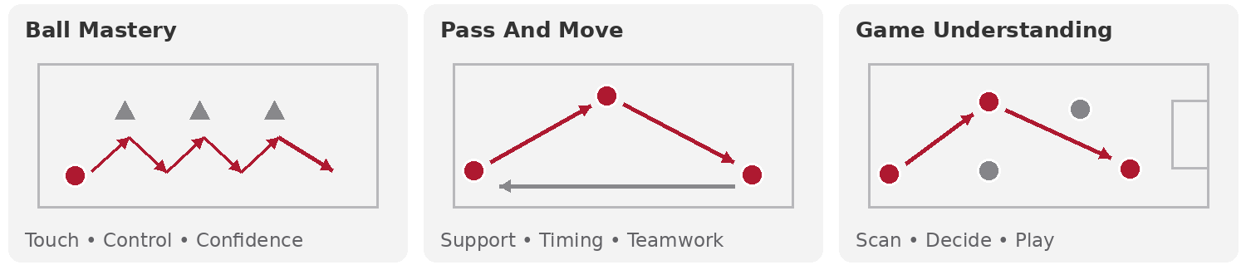
03 PROGRAM DELIVERY

Training And Equipment
SISL / IModel Regional | Boys And Girls
Indoor Turf | 1 X 90 Minutes Per Week
Indoor Gym | 1 X 90 Minutes Per Week
Goalkeeper Training | 1 Dedicated Session Per Week
Outdoor Training | 2 X 90-Minute Training Sessions Per Week
Age Groups | U14: 2013 | U15: 2012 | U16: 2011 | U17: 2010
Uniform And Equipment  Uniforms Are Purchased Separately From Registration Fees. Adidas Kit Budget: $350. Returning Members May Reuse Last Season’s Kit. Includes A Red Home Kit, White Away Kit, Training Kit, Tracksuit And Bag. A Training Ball Is Optional.  Facilities  Redeemer University Outdoor Turf And Indoor Dome; Sir Henry Newman; St. Thomas More; St. Jean De Brebeuf; Bishop Tonnos; Billy Sherring; Heritage Green; Italian Cultural Centre; Mohawk; School Gyms. | Development Support  Annual Periodization Models; Club Technical Framework.  Player Welfare  Insurance: Ontario Soccer. Canada Soccer National Club Licensing; Player, Coach And Parent Codes Of Conduct; Safe Sport Training And Education; MHUSC Policies. Applicable Ontario Soccer And SISL Operational Rules And Standards.

