01 THE PROGRAM

U6 And U7 Pre-Academy
Boys And Girls | 2020 And 2021 Born
SEASON COMMITMENT
November 1, 2026 To September 1, 2027
Mini-Matches And Small-Sided Tournaments During Training
Training And Development  One 60-Minute Training Session Per Week.  An Open Training Pool Within The Grassroots Stream.  Coaching And Team Structure  One Certified Head Coach, With Support Coaches For Each Gender And Licensed Technical Staff. | Competition  Mini-Matches And Small-Sided Tournaments Are Incorporated Into Training.  Player Pathway  Development Within The Mount Hamilton United Player Pathway.
Hamilton’s Only Club Offering The Full Player Pathway
Academy / Grassroots  Foundation And Confidence | → | Competitive  Team Play And Competition | → | OPDL  High Performance Development | → | OPL  Senior Performance
02 MEMBERSHIP

Fees And Payment
U6 And U7 Pre-Academy | Boys And Girls
Program Fee By E-Transfer  $495 | Credit-Card Surcharge  3%
Payment Schedule
1
UPON REGISTRATION
$495.00
Instalments Shown Before Any Applicable Credit-Card Surcharge.
Uniform Requirements  No Uniform Is Required For Pre-Academy. | Refund Policy  Refer To The Club’s Refund Policy Before Making A Payment.
Developing The Complete Player
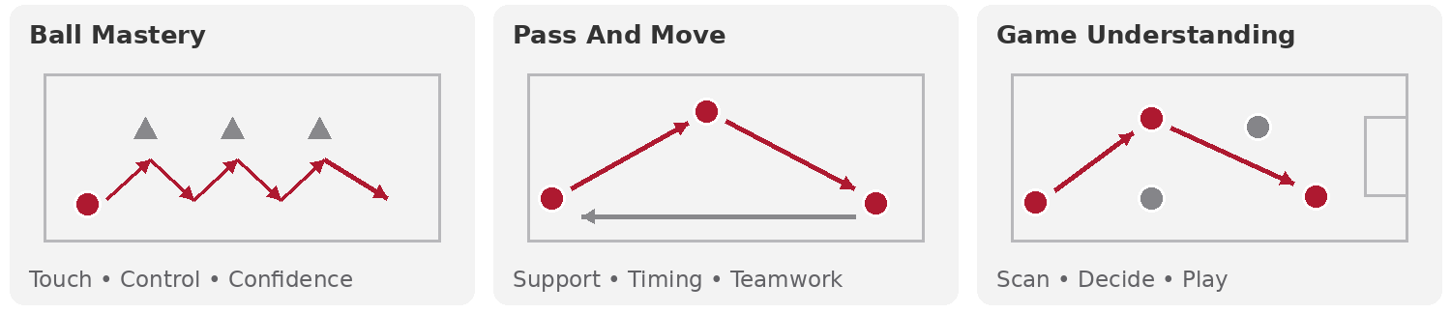
03 PROGRAM DELIVERY

Training And Equipment
U6 And U7 Pre-Academy | Boys And Girls
Indoor Season | November 2, 2026 To May 2027
Redeemer Indoor Turf | 1 X 60 Minutes Per Week
Outdoor Season | May To August 2027
Outdoor Grass | 1 X 60 Minutes Per Week
Uniform And Equipment  No Uniform Is Required For Pre-Academy.  Facilities  Redeemer University Indoor Dome And Macassa Park Outdoor Grass Fields. | Player Welfare  Insurance: Ontario Soccer And MHUSC. Canada Soccer National Club Licensing; Player, Coach And Parent Codes Of Conduct; Safe Sport Training And Education; MHUSC Policies. Applicable Ontario Soccer And Hamilton Soccer Grassroots Rules.

