01 THE PROGRAM

U9 Academy
Boys And Girls | 2018 Born
SEASON COMMITMENT
October 1, 2026 To September 5, 2027
5v5 Including Goalkeeper; No Standings
Training And Development  Indoor: Two 60-Minute Turf Sessions Per Week, Plus One Optional Gym Session.  Coaching And Team Structure  One Certified Head Coach Per Team, Supported By Licensed Technical Staff. Academy Teams Use Open Rosters Within The Grassroots Stream. | Competition  Indoor: Futsal And/Or Hamilton Soccer League (HSL), Mid-October 2026 To April 2027.  Outdoor: Official League Hosted By Hamilton Soccer, May/June To August 2027.  Player Pathway  Development Within The Mount Hamilton United Player Pathway.
Hamilton’s Only Club Offering The Full Player Pathway
Academy / Grassroots  Foundation And Confidence | → | Competitive  Team Play And Competition | → | OPDL  High Performance Development | → | OPL  Senior Performance
02 MEMBERSHIP

Fees And Payment
U9 Academy | Boys And Girls
Program Fee By E-Transfer  $1,745 | Credit-Card Surcharge  3%
Payment Schedule
1  UPON REGISTRATION  $872.50 | 2  DECEMBER 1, 2026  $523.50 | 3  MARCH 1, 2027  $349.00
Instalments Shown Before Any Applicable Credit-Card Surcharge.
Uniform Budget  Uniforms Are Purchased Separately From Registration Fees. Allow A $350 Kit Budget. Returning Members May Reuse Last Season’s Kit. | Refund Policy  Refer To The Club’s Refund Policy Before Making A Payment.
Developing The Complete Player
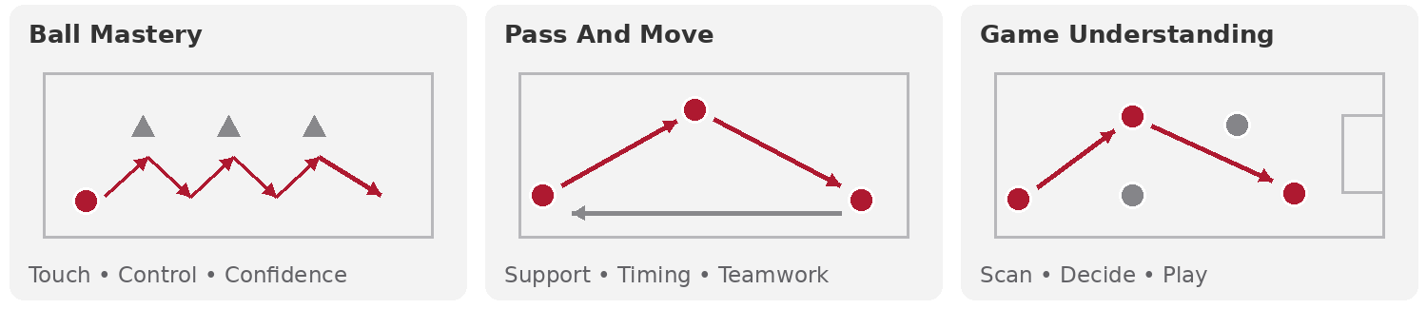
03 PROGRAM DELIVERY

Training And Equipment
U9 Academy | Boys And Girls
Indoor Season | November 2026 To May 2027
Redeemer Indoor Turf | 2 X 60 Minutes Per Week
Optional Gym Training | 1 Optional Gym Session Per Week
Outdoor Season | October 2026 And May To September 2027
Outdoor Grass Or Turf | 2 X 90 Minutes Per Week
Uniform And Equipment  Uniforms Are Purchased Separately From Registration Fees. Adidas Kit Budget: $350. Returning Members May Reuse Last Season’s Kit. Includes A Red Home Kit, White Away Kit, Training Kit, Tracksuit And Bag. A Training Ball Is Optional.  Facilities  Redeemer University Indoor Dome; Macassa Park; Hamilton School Gymnasiums. Outdoor Training Uses Grass And Turf Facilities; Gyms Support Futsal And Technical Training. | Development Support  Club Technical Framework; Annual Periodization Models.  Player Welfare  Insurance: Ontario Soccer And MHUSC Insurance. Canada Soccer National Club Licensing; Player, Coach And Parent Codes Of Conduct; Safe Sport Training And Education; MHUSC Policies. Hamilton Soccer Operational Rules.

